**ASSIGNMENT 9.4**

**PROBLEM STATEMENT:**

Transfer streaming data from your local file system to HDFS using flume spool directory.

**PROCEDURE 1:**

Creation of a folder named spool is done along with 2 files say sample1 and sample2 for example

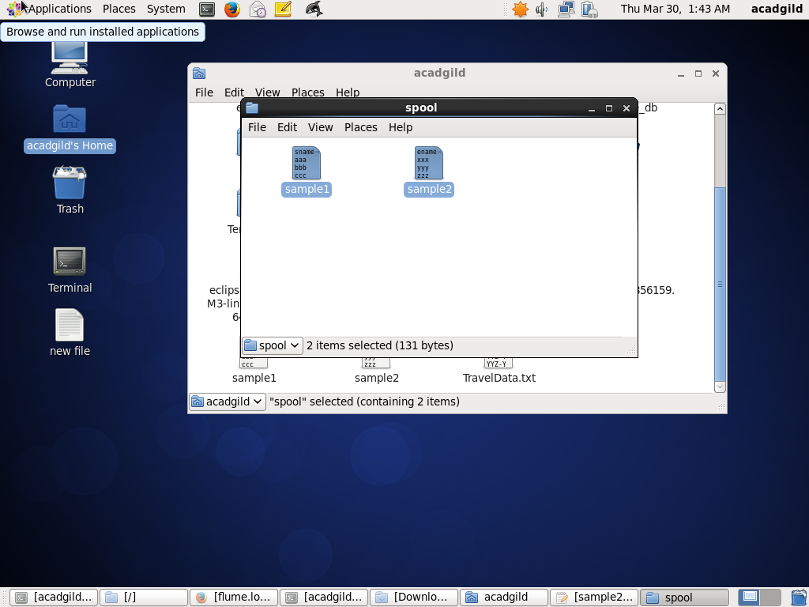

**PROCEDURE 2 :**

The process involves moving the configuration file into conf folder of flume

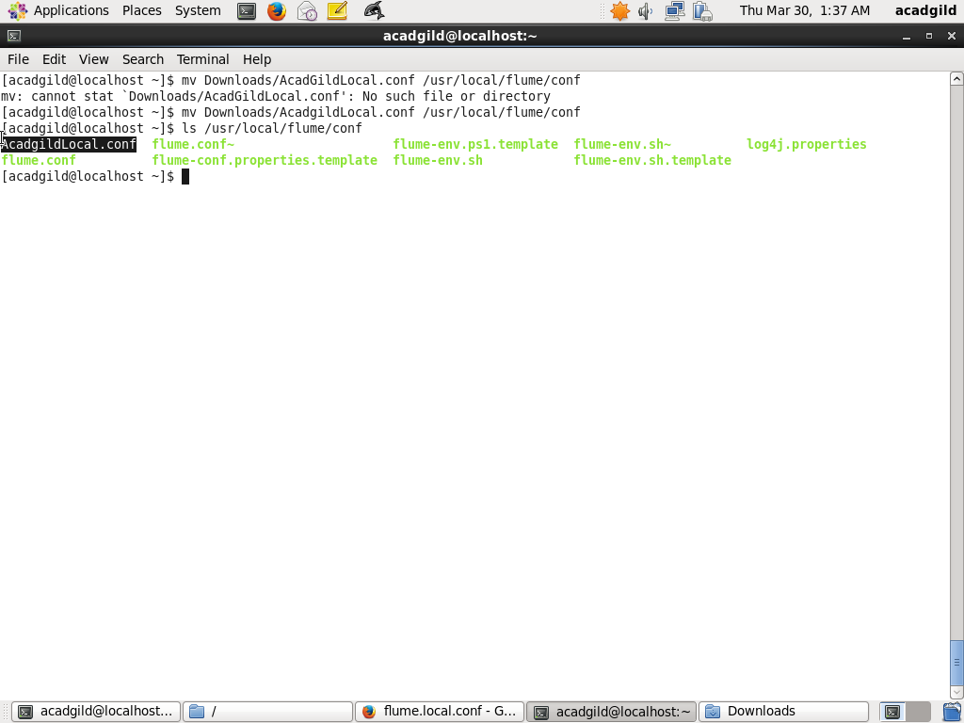

**PROCEDURE 3:**

creation of the output directory

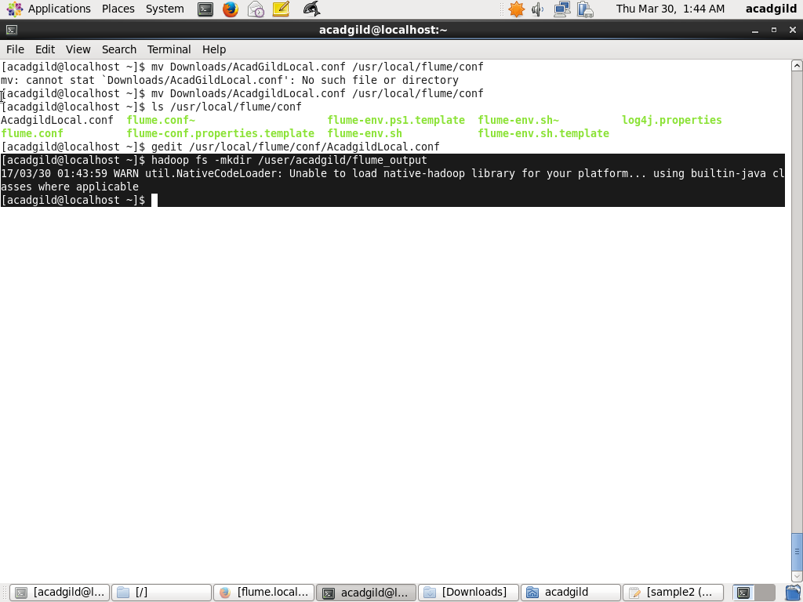

**PROCEDURE 4:**

modification of .conf file according to my path

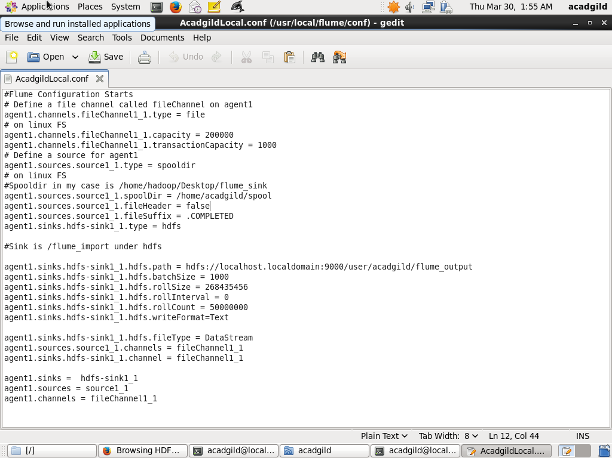

**PROCEDURE 5:**

running the flume agent

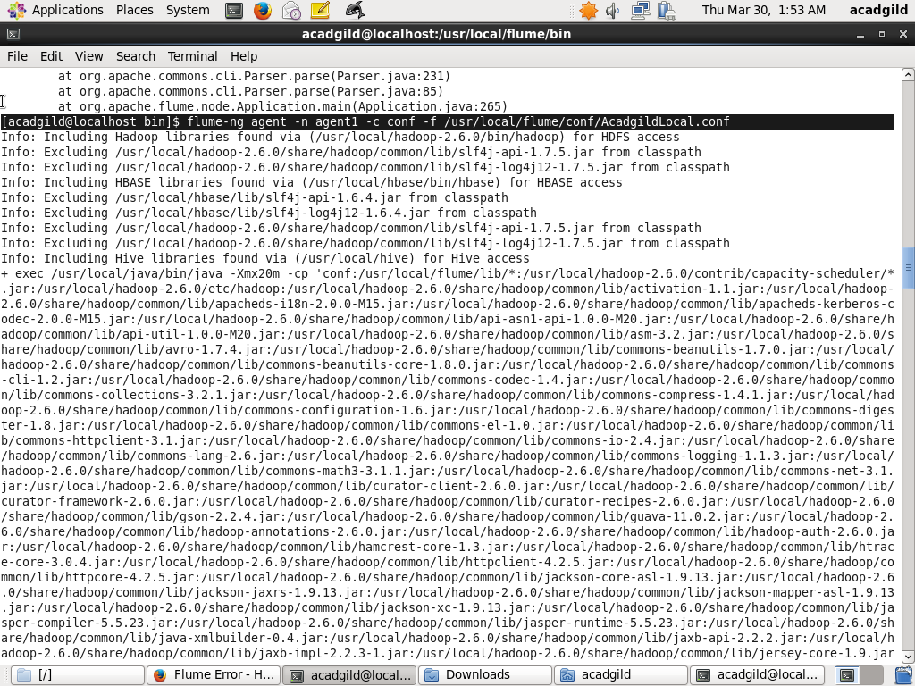

**PROCEDURE 6:**

result

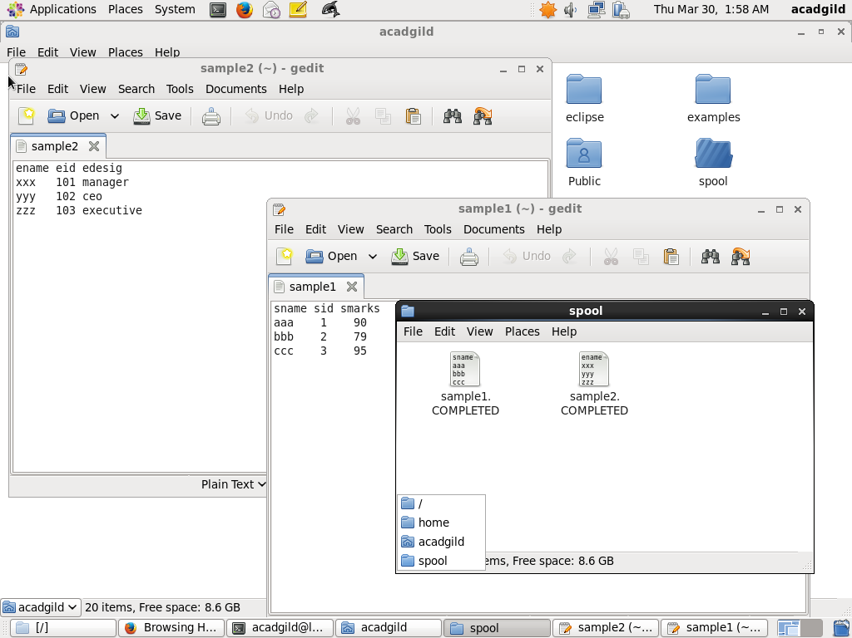

**PROCEDURE 7:**

output stored on hdfs

